Sri Lanka Institute of Information Technology

Lab Submission

06

**IT24102798**

**Sooriyabandara U.R.G.W.K.**

**Probability and Statistics | IT2120**

B.Sc. (Hons) in Information Technology

**Exercise**

1. An IT company claims that their newly developed learning platform improves student performance in online tests. According to previous data, 85% of students who used the platform passed their online tests. A batch of 50 students are selected at random who have completed the course using this platform. Let X denote the number of students who passed the test out of 50 students.
2. What is the distribution of X?

* Random Variable X has Binomial Distribution with n = 50 and p = 0.85.

1. What is the probability that at least 47 students passed the test?

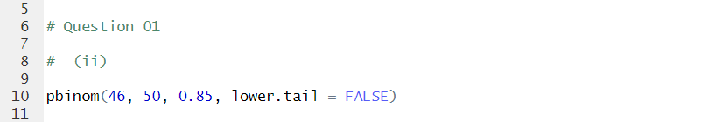

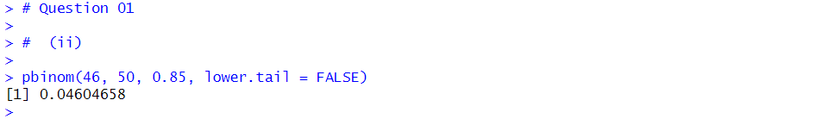

1. A call center receives an average of 12 customer calls per hour.
2. What is the random variable (X) for the problem?

* Number of Customer Calls on a given hour.

1. What is the distribution of X?

* Random Variable X has Poisson Distribution with lambda = 5.

1. What is the probability that exactly 15 calls are received in an hour?

